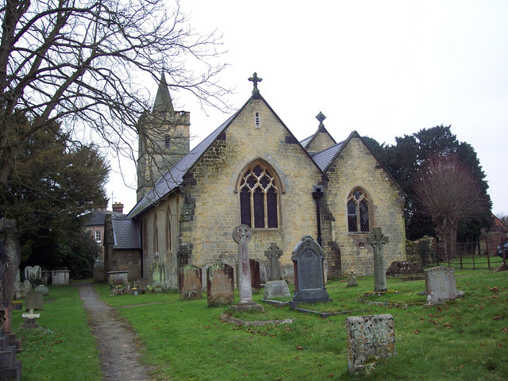

ST MICHAEL’S CHURCH & CHURCHYARD WORKING PARTY DATES:

Saturday 11th February

Saturday 11th March

Saturday 1st April

Time: 10am to 12 noon

All volunteers warmly welcomed to help keep our village church looking beautiful inside and out. There are always plenty of jobs that need your help, no experience necessary. Refreshments served.

